
Croydon’s
Childcare
Sufficiency
Assessment
2023
CONTENTS

1. Summary

2 Demand for childcare

3 Supply of childcare

4 Funded early education

5 Sufficiency of places

6 Prices

7 Quality of childcare in our area

8. Parents/carers and providers views of sufficiency in our local area

1. Summary

Croydon Council is required by law to ‘report annually to elected council members on how they are meeting their duty to secure sufficient childcare and make this report available and accessible to parents’. We have prepared this report in order to meet this duty.

Having sufficient childcare means that families are able to find childcare that meets
their child’s learning needs and enables parents to make a real choice about work
and training. This applies to all children from birth to age 14, and to children with
disabilities. Sufficiency is assessed for different groups, rather than for all children in
the local authority.

In this report, we have made an assessment of sufficiency using data about the need
for childcare and the amount of childcare available.
We use information about childcare sufficiency to plan our work supporting the local
childcare economy.

This report was compiled using data from the Office for National Statistics; Ofsted; the Croydon Observatory; and the Early Years Sufficiency Team. Views of parent/carer and childcare providers were gathered using an online questionnaire.

In the March 2023 Budget, the government announced plans to extend the existing 30-hour funded entitlement, which is currently available to eligible working families of three- and four-year-olds, to all eligible working families of children aged nine months and above by September 2025.
- From April 2024, working parents of two-year-olds will be able to access 15 hours of free childcare.
- From September 2024, 15 hours of free childcare will be extended to all children from the age of nine months.
- From September 2025, working parents of children under the age of five will be entitled to 30 hours free childcare per week.
This staggered approach will give childcare providers time to prepare for the changes, ensuring there are enough providers ready to meet demand.

At this point in time, we believe we have sufficient childcare available across the borough for all age groups. The age groups in early years, which are determined by the adult:child ratios set out in the Statutory framework for the early years foundation stage, are 0-2 years; 2-3 years; 3-4 years.

We also believe we have sufficient capacity across the Borough to provide enough places from April 2024 when the first phase of the funding for 2 year olds of eligible working parents/carers begins with 15 hours per week x 38 weeks per year.
To qualify for this funding, each parent needs to be working and earning the equivalent of 16 hours a week at national minimum/living wage and under £100,000 adjusted net income per year. This means that each parent needs to earn from just over £8,600 per year to be eligible for 15 hours a week of childcare during term time. Coupled with the current eligibility criteria for receiving funding (families in receipt of certain benefits and with a household income of £16,190 a year or less before tax), it is likely that almost every 2 year will be entitled to 15 hours a week of funded childcare.

Fewer settings current provide for children in the 0-2 years age group. The adult:child ratio is 1:3 and settings are finding it difficult to recruit staff. The Early Years Sufficiency Team is working to evaluate demand and capacity of places for babies, ahead of phase 2 of the reforms which see 15 hours per week x 38 weeks of funded childcare for working families of children from the term after they turn 9 months old.

Local authorities and schools will be given funding for what’s known as “wraparound care”. This is to ensure that all parents of school-age children can access childcare in their local area from 8am – 6pm. It is expected that, by September 2026, most primary schools will be able to provide their own before and after school care.

There is a growing number of young children being identified as having additional Special Educational Needs and Disabilities (SEND) in Croydon. The needs of these children will need to be taken into account when considering both early years childcare and school “wraparound” childcare.

The Council’s Early Learning Team continue to work to support settings in offering high quality early education and childcare to all of Croydon’s very young children. Croydon’s Family Hub model with foci on early health and education for under 5s will further support the Borough’s youngest children.

2 Demand for childcare

2.1 Population of early years children
In total, there are 25,200 children under the age of five living in Croydon. These children may require early years childcare.

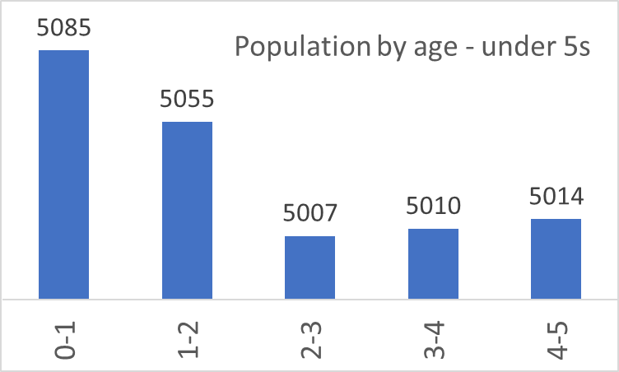
Table 1. Numbers by age
Age | Number of children
Age 0 | 5,085
Age 1 | 5,055
Age 2 | 5,007
Age 3 | 5,010
Age 4* | 5,014
* Some four-year-olds will have started reception

Graph 1 .
2.2 Population of school age children
In total there are 37,644 children aged 5-11, and 15,855 children aged 12-14 living in our local authority. Families are entitled to support with childcare for children up to the age 14. These children may require childcare before and after school, and/or during the school holidays.

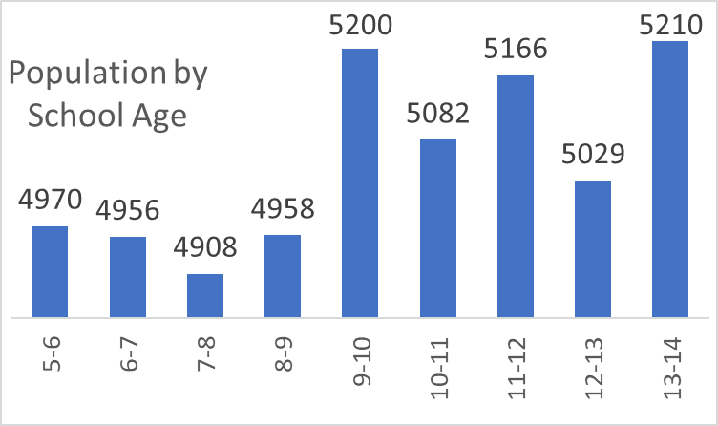
Table 2. Numbers by age
Age | Number of children
Age 5 | 4,970
Age 6 | 4,956
Age 7 | 4,908
Age 8 | 4,958
Age 9 | 5,200
Age 10 | 5,082
Age 11 | 5,166
Age 12 | 5,029
Age 13 | 5,210
Graph 2
2.3 Number of children with special educational needs and disabilities
Children with special education needs and disabilities (SEND) are entitled to support with childcare up to the age of 18 The number of children/young people with an Education, Health and Care (EHC) Plan in our local authority is: 4,556*
Age Group | Number of children with an EHCP
Birth to school age | 155
Primary school (reception to year 6) | 1,742
Secondary school (year 7 to 13) | 2,017
Post secondary school (ages 18-25) | 642

Table 3. *as at November 2023.

2.4 Children’s needs change over time and are identified at different ages. Among the youngest children, SEND may only be identified when they start in a setting or school, and it can take some time from needs being identified to an EHC plan being issued.

2.5 The portage team support pre-school children with complex needs both at home and in groups. Currently 62 children with highly complex needs are being supported in the home. This is an increase from last year (November 2022) when 46 children were accessing portage support.

2.6 There are currently two specialist nursery classes in Croydon. St Giles School, in the south of the Borough, offers 6 full time equivalent (fte) places for children with complex medical needs, complex physical disabilities and / or Severe (SLD) or Profound and Multiple Learning Difficulties (PMLD) Learning Difficulties and Winterbourne Infant and Nursery School, in the north of the Borough, has an Enhanced Learning Provision (ELP) as part of their Nursery provision. The ELP provides high quality specialist teaching for up to 6fte children with social communication difficulties. Willow Tree Nursery, at Red Gates School, which provided an Enhanced Learning Provision (ELP) setting for 6 fte children with severe learning difficulties and autism is currently suspended.

2.7 Many children have SEND but do not have an EHC plan. Pre-school settings apply to the LA for Special Educational Needs Inclusion Funding (SENIF) to support children with additional needs. The number of children receiving SENIF in increasing year on year.
September 2021 - August 2022 - 178 pre-school children received SENIF
September 2022 - August 2023 - 250 pre-school children received SENIF

In the Autumn term last year (2022) there were 45 successful applications for SENIF. This year (September 2023- November 2023) there have been 146 successful applications for SENIF. This represents a 224% increase in the number of pre-school children being identified an supported with additional needs.

Supply of childcare

3.1 Number of early years providers and places
There are a number of different types of Early Education and Childcare providers, each offering a variety of options for families:

 | Provision | Description of offer | Ofsted
PVIs | Day Nursery | Generally open all year round; usual core hours 8am – 6pm; registered with Ofsted to take children from 3 months – 5 years; can be a stand-alone setting or part of a chain of nurseries; often privately run with a single proprietor | Must join the Early Years register if caring for children aged from birth to 31 August after their fifth birthday.  Need to meet all the safeguarding and welfare and the learning and development requirements of the Statutory requirements for the early years foundation stage.
PVIs | Pre-school | Usually operate in line with school hours so open term time only, 9am – 3.30pm; often run from church/community halls; often “pack-away” (need to clear rooms on a daily or weekly basis to allow for other uses);  Often committee run
PVIs | Independent | Operate as part of an independent school; term-time only; hours based on the school day | Not required to register on early years register unless taking children under 2 years
 | Childminder | Most commonly a lone practitioner working from own home; all year round provision; usually core hours 8am-6pm; able to work with assistants; several now registered with a Childminding Agency | Must join the Early Years register if caring for children aged from birth to 31 August after their fifth birthday.  Need to meet all the safeguarding and welfare and the learning and development requirements of the Statutory requirements for the early years foundation stage.
School | Maintained Nursery School | Stand-alone nursery school with head teacher and at least one Qualified Teacher Status staff member; qualified school SENDCo (Special Educational Needs Co-ordinator); term-time only; usual hours 9am-3.30pm | Not required to register on early years register unless taking children under 2 years
School | Nursery Class | Operate as part of a school or academy, led by school headteacher/principal; term-time only; usual hours 9am-3.30pm
 | Nanny/Au pair | Also known as ‘home childcarers’; look after children of any age in the child’s own home.  Can look after children from 2 different families at the home of one of the families. | Only need to register on the voluntary part of the Childcare Register if want parents to be able to get help with childcare costs.
Table 4

In total, there are 543 early years childcare providers in our local authority, offering a maximum of 10,273 full time equivalent early years childcare places (see table 5).

Type of provision | Number of providers | Number of registered places
Childminders* | 332 | 830
Nursery classes in schools | 47 | 1,624
Maintained nursery schools | 5 | 369
Day Nurseries | 109 | 5,689
Pre-schools | 40 | 1,360
Independent schools | 10 | 401
Table 5. The data in this table was correct in November 2023
*Childminders usually have 2 or 3 early years aged children. For the purpose of this table, an average of 2.5 children has been assumed.

Graph 3. Percent of places by setting type.

3.2 For private, voluntary and independent nurseries and childminders, the number of registered places represents the maximum number of children who can be on the premises at any given time. In practice, many providers choose to operate below their number of registered places.

3.3 Early years vacancies
In Croydon we ask providers to report vacancies to us so we can help promote them. Not all choose to do this and therefore we do not have current data on the number of vacancies each setting type has. In general, vacancy rates are higher in the autumn, after older children have moved to school. As stated above, many providers do not operate at capacity numbers to ensure a lower adult:child ratio.

3.4 Early years atypical hours
Childcare is most commonly delivered during the typical working day – between 8am and 6pm on weekdays. Some parents require childcare outside these times in order to fit with their work or other responsibilities.
70 day nurseries in Croydon offer atypical hours on weekdays, with the majority of these settings operating from 7.30/7.45am and/or until 6.30pm. There are no known settings operating at weekends. It is unknown how many childminders offer childcare outside of the typical hours or at weekends.

3.5 Number of school age providers and places
In total, there are 55 providers of childcare for primary school age children during term time, and 22 providers of childcare for primary school age children during the holidays.

Type of provision | Number of providers | Number of registered places
Breakfast club – primary school | 55 | 2,023
After-school club – primary school | 55 | 2,371
Holiday club | 22 | 1,378
Childminders | 332 | 830
Table 6 . *Childminders usually have 2 or 3 school aged children. For the purpose of this table, an average of 2.5 children has been assumed.

4 Funded early education
4.1 Introduction to funded early education

- All children aged 3 and 4 are entitled to 15 funded hours per week over 38 weeks (570 hours) until they start reception class in a maintained school or academy. This is known as the ‘universal offer’. Parents can access these 570 hours over more weeks, with less hours per week, depending on each setting’s offer. This is known as a ‘stretched offer’.

- Children aged 3 and 4, where both parents are working, or from lone parent families where that parent is working, are entitled to an additional 15 funded hours per week (1140 total hours) until they start reception class in school
- Some children, from the term after their 2nd birthday, are entitled to 15 hours per week, over 38 weeks per academic year. The criteria for these funded hours is:
- Families are in receipt of certain benefits (including low income families in receipt of in-work benefits)
- Child is looked after by a local authority
- Child has an education, health and care (EHC) plan
- Child gets Disability Living Allowance
- Child has left care under an adoption order, special guardianship order or a child arrangements order
- Some families who have ‘no recourse to public funds’ linked to an economic criteria
4.2 Nationally, about 40% of 2 year olds are entitled to this offer, but the proportion varies by area.

4.3 Parents do not have to use all the hours of their funded entitlement. They may also choose to split them between providers.

4.4 In April 2023 the Chancellor of the Exchequer introduced a number of significant changes to early years education and childcare. These childcare reforms will change the offer provided to parents and carers significantly over the next 3 years. Table 7 explains the changes the reforms will bring and timeline of when these will be implemented.

Timescale | Reforms
September 2023 | - Childminder grants to become available to those entering the profession.
April 2024 | - 15 hours of childcare each week for 38 weeks a year for eligible working parents of 2YO’s.
September 2024 | - 15 hours a week of childcare for 38 weeks a year for eligible working parents of children aged 9 months plus.  - The National Wraparound Care support begins.
September 2025 | - 30 hours of childcare each week for 38 weeks a year for eligible working parents of children aged from 9 months to school age.
September 2026 | - All schools able to offer 8am-6pm wraparound on their own or in partnership
Table 7

4.5 Take up of funded early education - 2 year olds (2YOs)
In Croydon, the number of eligible 2 year olds who take up a funded place is lower than both National and London figures. The uptake of 2YO funded places is shown in the table below: As of November 2023, the number of funded 2 year olds in Croydon settings is 911.
Year | No of 2YOs eligible for funding - Croydon | No. of funded 2YOs - Croydon | % of all eligible 2YOs - Croydon | % of all eligible 2YOs - Nationally | % of all eligible 2YOs - London
2023 | 1549 | 890 | 57.5% | 73.9% | 65.2%
2022 | 1410 | 903 | 64% | 72% | 72%
2021 | 1825 | 803 | 44% | 62% | 50%
2020 | 2069 | 1014 | 49% | 69% | 59%
Table 8. *Numbers as of July 2023
Graph 4.

4.6 Take up of funded early education - 3 and 4 year olds – universal offer
(15 hours p.w)

Year | No. of funded 3/4YOs - Croydon | % of all eligible 3/4YOs - Croydon | % of all eligible 3/4YOs - National | % of all eligible 3/4YOs - London
2023 | 8,819 | 87% | 94% | 89%
2022 | 8,915 | 84% | 92% | 86%
2021 | 8,935 | 80% | 90% | 83%
2020 | 9,624 | 85% | 93% | 88%
Table 9. This data is based on Department for Education data released July 2023

Graph 5. Take up of 3/4 year old funding by year.

4.7 3 and 4-year-old funded entitlement applications (extended hours, 30 hours p.w)
This funding is for working parents and, if eligible, starts from the beginning of the term after the child’s 3rd birthday. Parents who think they are entitled to a 30 hour extended hours place apply for this online through the Government’s Childcare Support website. The same website is used to apply for tax free childcare and parents can apply for either or both. If a parent is eligible, the system creates a code which they can use with their chosen childcare provider. If they are ineligible, they will still be entitled to the universal 15 hours of early education and childcare.

Year | Number of Children Accessing Extended Hours Funding - Croydon
2023 | As at November 2023, 1,697 children are accessing extended hours funding
2022 | 2,092
2021 | 2,115
2020 | 2,248
Table 10. This data is based on Department for Education data released June 2022. Data for 2023 not yet available

4.8 Providers offering funded early education places
Providers are paid directly by government for delivering funded early education. They are not required to offer funded places to parents, but of course parents may choose to use a different provider if they do not. Some providers offer a restricted number of funded places.

5 Sufficiency of places

5.1 Places required from April 2024
The Department for Education supplied all local authorities with estimates of the
number of places which could be required to fulfil the demand of the expanded
funding streams available to children of working families from April 2024. Tables 11-
13 below show, by locality, the estimated increase in demand for the wards in
Croydon. Please note, figures shown are full time equivalent places (fte) which is
assumed as 2 children each receiving the 15 hours funded places.

Central | Additional places (fte) required April 2024 | Further Additional places (fte) required Sept 2024 | Further Additional places (fte) required April 2024
Addiscombe East | 2 | 1 | 11
Addiscombe West | 6 | 4 | 33
Broad Green | 7 | 4 | 36
Park Hill & Whitgift | 2 | 1 | 11
Selhurst | 3 | 2 | 16
Shirley North | 2 | 1 | 12
Shirley South | 4 | 2 | 21
Waddon | 8 | 5 | 43
Woodside | 5 | 3 | 26
 | 38 | 23 | 210
Table 11

North | Additional places (fte) required April 2024 | Further Additional places (fte) required Sept 2024 | Further Additional places (fte) required April 2024
Bensham Manor | 5 | 3 | 26
Crystal Palace & Upper Norwood | 4 | 2 | 20
Norbury & Pollards Hill | 3 | 2 | 15
Norbury Park | 5 | 3 | 29
South Norwood | 6 | 4 | 33
Thornton Heath | 6 | 3 | 31
West Thornton | 9 | 6 | 52
 | 37 | 23 | 206
Table 12

South | Additional places (fte) required April 2024 | Further Additional places (fte) required Septl 2024 | Further Additional places (fte) required April 2024
Coulsdon Town | 3 | 2 | 18
Kenley | 5 | 3 | 27
New Addington North | 2 | 1 | 11
New Addington South | 3 | 2 | 17
Old Coulsdon | 3 | 2 | 14
Purley & Woodcote | 5 | 3 | 29
Purley Oaks & Riddlesdown | 4 | 2 | 19
Sanderstead | 4 | 2 | 19
Selsdon & Addington Village | 2 | 1 | 10
Selsdon Vale & Forestdale | 4 | 2 | 23
South Croydon | 12 | 7 | 64
 | 46 | 26 | 250
Table 13

5.2 Across the Borough, it is estimated that an additional 121 fte places will be required
for April 2024; a further 72 fte places in September 2024; and a further 666 places
in September 2025 when the funding increases from 15 hours per week to 30
hours per week for all eligible children of working families.

6 Prices

6.1 Prices of early years childcare
The Government funding is paid at an hourly rate. Currently the rates in Croydon are: £9.63 per hour for funded 2 year olds and £5.99 per hour for funded 3 and 4 year olds (both the universal 15 hours and the extended hours are paid at this rate).
For early years childcare outside the funded entitlements, most settings offer a range of options for families. Table 12 below shows average hourly rates, as reported to us by settings. There may be variations to prices based on the number of hours a family uses, with reductions for longer hours, or discounts for sibling groups. There may be additional payments for additional services, e.g. lunch and other meals which are not included in these prices.
Generally the charges vary by age group in line with statutory adult:child ratios which are 1:3 for 0-2 year olds; 1:5 for 2-3 year olds and 1:8 for 3-4 year olds (1:13 when a qualified teacher or EY teacher is present).

Setting type | Average Hourly Rate  0-2 year olds |  |  | Average Hourly Rate  2-3 year olds |  |  | Average Hourly Rate  3-4 year olds
 | South | Central | North | South | Central | North | South | Central | North
Day Nursery | £7.40 | £6.80 | £7.50 | £7.30 | £7.00 | £6.80 | £7.00 | £6.70 | £6.80
Pre-school | N/A | N/A | N/A | £6.70 | £6.60 | £8.25 | £6.00 | £6.40 | £7.90
Schools | N/A | N/A | N/A | £6.00 | £7.80 | £7.30 | £5.80 | £6.80 | £6.70
Childminders | Average £7.30
Table 14.
6.2 Prices of school age childcare
For school age children, families can access childcare through breakfast clubs (these are usually run by schools); after-school clubs (again, usually run by schools); childminders and holiday clubs (often using schools as venue by run by independent businesses). The average cost per hour for each of these services is detailed below in localities:

Provision type | Average Hourly Rate
 | South | Central | North
Breakfast club | £4.80 | £4.30 | £4.10
After-school club | £4.80 | £4.80 | £4.40
School age childminder | Average £7.30
Holiday club | £4.68 | £3.20 | £3.90
Table 15
6.3 In addition, a small number of tuition centres offer places for children after school and at the weekends/during holidays. These include academic tuition centres and arts centres. Prices vary from £10-£30 per hour.
7 Quality of childcare in our area

7.1 Ofsted inspection grades
All childcare providers must register with and be inspected by Ofsted, who give them an overall grade for the quality of their provision. Childminders and private and voluntary providers are on the Early Years Register, and schools and standalone maintained nursery schools are on the Schools’ register. The grades for both registers are equivalent. Schools with nurseries have an overall inspection grade for the whole school and most also have a separate early years grade.

7.2 Both schools and early years providers have four possible Ofsted grades: ‘outstanding’, ‘good’, ‘requires improvement’, and ‘inadequate’. Some providers are still awaiting their first full inspection.

Graph 6. Data correct as of November 2023

7.3 To receive funding from the Local Authority, settings cannot be graded as ‘inadequate’; to receive funding for 2 year old places, settings must be judged ‘good’ or ‘outstanding’. Settings are able to offer funded places for 2, 3 and 4 year olds whilst they are awaiting their first Ofsted grading.

7.4 When providers do not have any children on site at the time of their first inspection, they are given an Ofsted grade of ‘met’ or ‘not met’. This shows whether they are meeting the requirements for Ofsted registration, and usually happens when new providers are being set up. The graph below shows the percent of Ofsted gradings for Croydon settings.

8 Parents/carers and providers views of sufficiency in our local area
(Copy of full responses available on request)

8.1 Parent/carers survey
An online questionnaire was sent out to parents/carers of children currently attending early years settings across the Borough to assess the need for places in light of the Childcare Reforms being rolled out from April 2024.. There were a total of 939 responses. 857 respondents said they were currently accessing childcare and 82 said they were not.

8.2 Respondents were asked what type of childcare they used.
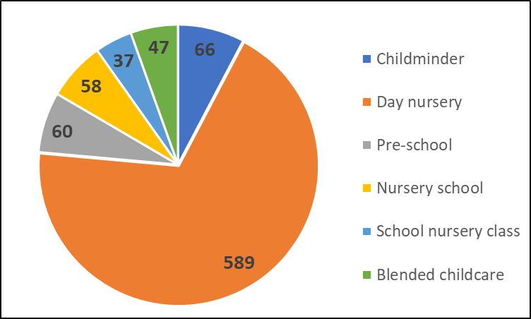
Type of Provider | No. of children
Childminder | 66
Day nursery | 589
Pre-school | 60
Nursery school | 58
School nursery class | 37
Blended childcare | 47
Table 16 Graph 7

8.3 Respondents, who are currently accessing places, were asked how those places were paid for.
497 respondents were paying for all of their childcare hours.
222 respondents were blending both government funded hours with paid for hours.
138 respondents were accessing funded hours only.
Of the 138 respondents who were only accessing funded hours, 87 were accessing 2 yr old funding; 114 were accessing 15 hours of 3/4 yr old funding; and 159 were accessing the 30 hours (extended) 3/4 yr old funding.

8.4 Almost all respondents were interested in accessing funding places.
The majority were keen to access 2 yr old funding for both 15 hours p.w. and 30 hrs p.w. (477 respondents);
266 respondents would access both the 2 yr old funding (15 hrs p.w. and 30 hrs p.w.) and the funding available to children from 9 months old (15 hrs p.w. and 30 hrs p.w.);
94 respondents were interested in the funding for 9 months old (15 hrs p.w. and 30 hrs p.w.) only.

8.5 Finally respondents were asked how the funding available under the Childcare Reforms would affect them. There were 829 responses:
346 said that they would use the funding to increase the number of hours their child attended an early years setting.
483 said that they would not increase the number of hours attended but it would reduce their childcare costs.
8.6 Provider survey
Providers of early years childcare were sent a questionnaire in relation to their capacity to increase the number of places available when the Childcare Reforms were rolled out from April 2024. A total of 127 responses were received.

The majority of responses were from childminders and day nurseries. All 5 maintained nursery schools responded.

Graph 8

8.7 Settings were asked about numbers of children and funded places. Of the 127 respondents, 100 accepted funded children and 27 only provided for fee-paying children. The majority of settings currently provide for 2 yr olds and of the 27 settings which do not, 12 said they are considering it from April 2024 (it was mostly school settings which are not considering taking 2 yr olds). The main reasons cited for not expanding provision for 2 yr olds included lack of accommodation space and concerns over funding rates.

8.8 Settings were then asked about taking babies (from 9 months old). 40 of the 127 settings currently provide for babies and a further 57 settings said they were considering providing for babies from September 204. The main reasons cited for not expanding provision for babies included lack of suitable accommodation and availability of staff.

Census 2021 Englan5210d and Wales Dec 2022
ONS, Mid Year Population Estimates, 2021, Released Dec 2022.
Full time places record children who attend for as many hours as a setting is open on a daily basis. In many cases two children may attend part time, taking up a full time equivalent place (fte).
From the term after a child’s 3rd birthday
For more information see https://reports.ofsted.gov.uk/about-our-inspection-reports

