



Childcare Sufficiency Assessment
2024
Katie Adams
EYandChildcareExpansion@walsall.gov.uk

PROUD OF OUR PAST OUR PRESENT AND FOR OUR FUTURE

Contents
STATUTORY DUTY 4
TYPES OF CHILDCARE 4
Full day care 4
Childminders 4
Home carers 4
Pre-school playgroups 4
Out of school (Wraparound) provision 5
Holiday play schemes 5
Nursery schools 5
Nursery Classes 5
ABOUT WALSALL 6
OVERALL SUFFICIENCY IN WALSALL 7
Funded early education for 2-year-olds (Time 2 start). 7
Universal (15 hour) funded early education for 3- and 4-year-olds. 7
Working parent’s (30 hour) funded early education for 3- and 4-year-olds. 7
Early years childcare outside the funded entitlements 8
Childcare before and after school 9
Childcare during the school holidays 9
Childcare for children with special educational needs and disabilities (SEND) 9
DEMAND FOR CHILDCARE 10
Population of early years children 10
Population of school age children 10
Number of children with special educational needs and disabilities 11
Changes to population of children in our area 11
SUPPLY OF CHILDCARE 12
Number of early years providers and places 12
Early years vacancies 13
Number of school age providers and places 13
School age vacancies 13
School age atypical 13
FUNDED EARLY EDUCATION 15
Introduction to funded early education 15
Proportion of 2-year-old children entitled to funded early education. 16
Take up of funded early education 16
PRICES 16
Prices of school age childcare 16
QUALITY OF CHILDCARE 17
Ofsted 17
Registration of Childcare provision 17
Ofsted Inspections and Judgements 17
Quality of childcare in Walsall 19
Providers with met/not met grade 19
EARLY YEARS AND CHILDCARE EXPANSION PROGRAMME 20
Spring Budget 2023 20
Autumn 2023 20
April 2024 20
September 2024 20
September 2025 20
September 2026 20
RECOMMENDATIONS 21
Supply and demand of childcare 21
Eligibility and entitlements take-up 21
Capacity and recruitment 21
Communications and Marketing 22

STATUTORY DUTY
‘Each Local Authority is required by law to report annually to elected council members on how they are meeting their duty to secure sufficient childcare and make this report available and accessible to parents’.
(Source: Statutory guidance on Early Education and Childcare, effective from 1 September 2017)
Having sufficient childcare means that families can find childcare that meets their child’s learning needs and enables parents to make a real choice about work and training. This applies to all children from birth to age 14, and to children with disabilities. Sufficiency is assessed for different groups, rather than for all children in the local authority.
In this report, sufficiency is assessed using data about the need for childcare and the amount of childcare available.
Information is used about childcare sufficiency to plan and support the local childcare economy.
Parents and carers can find more information on childcare via the Walsall Families Information Service (FIS) Walsall FIS Homepage (mywalsall.org)

TYPES OF CHILDCARE

Full day care
Full day care settings care for and support children’s learning in line with the ages and stages of development of children from 3 months to 5 years and are predominately open from 8.00am to 6.00pm, some are open even longer hours. Most are open from Monday to Friday, but a few may open at weekends to help support parents’ different working patterns. Day nurseries operate all year round usually, except for bank holidays. Some nurseries close between Christmas and New Year, while others remain open. Most offer the free early education places that are available to 2, 3 and 4-year olds.

Childminders
Registered childminders are self-employed childcare professionals who work in their own homes. They care and support each child’s learning in line with their age and stage of development. They are registered for small numbers of children and will often care for a range of ages. Childminders may also offer flexibility to accommodate parents working patterns e.g. evening and weekends.

Home carers
Home carers are usually nannies who care for children of any age up to their 18th birthday wholly or mainly in the child’s own home, and care for children from no more than two families. They are not required to register with Ofsted but may choose to do so, on the voluntary part of the Childcare Register.

Pre-school playgroups
Pre-schools provide care and support children’s learning in line with ages and stages of development for children between 2 and 5 years. Most pre-schools will be open five mornings a week, with the majority providing afternoon sessions as well. Pre-schools and playgroups tend to run term time only, from around 9am to lunchtime or from lunchtime to around 3 or 4pm.

Out of school (Wraparound) provision
These are often referred to as Breakfast or After School Clubs. They provide play opportunities for school age children at times when schools are not open. They can operate before school in the mornings, from the end of the school day and at the end of the working day. It is important to note that many of the out of school provisions respond to fluctuating community need and the majority are run by schools themselves.

Holiday play schemes
Holiday play schemes, take place during school holiday periods and may be run by a school, private or voluntary organisations.

Nursery schools
This type of provision is based within schools maintained by the local authority and accept children from 2/3 years to compulsory school age. Sessions operate during school hours, term time only, generally with one in the morning and one in the afternoon.

Nursery Classes
This type of provision is based with in primary schools that have a specific nursery class. They are found in both LA maintained schools and academies. Sessions operate during school hours, term time only, generally with one in the morning and one in the afternoon. Accepting children from 3 years to compulsory school age. Some schools do have separate provision for 2 year olds.

ABOUT WALSALL
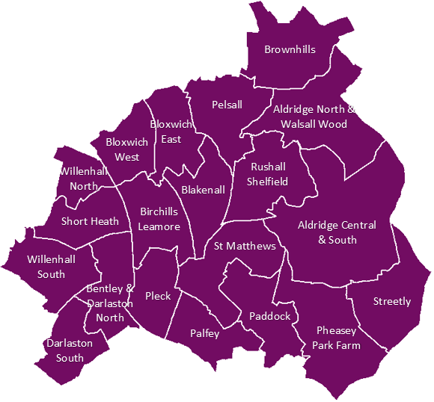
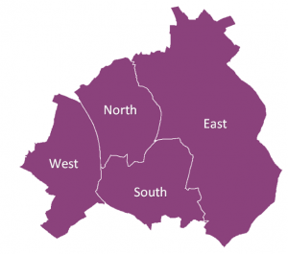
Walsall is made up of four localities, North, Central and South, East and West. These localities are then split into 20 wards.

The Mid-2019 Population Estimates show that Walsall has 285,478 residents. Under 4's make up 6.8% of Walsall's population (19,501). There was a 0.6% percentage change in total LA population from mid-year 2021 to mid-year 2022 in Walsall. The percentage change in total LA population from mid-year 2021 to mid-year 2022 for the West Midlands was 1.1%, this increase was from international migration.
This table shows the population of people aged 0 to19 years by localities.
Table 1 | Age (Years) |  |  |  | Population aged 0 - 19
 | 0 - 4 | 5 - 9 | 10 - 14 | 15 - 19 | Total | %
North | 4,696 | 4,783 | 4,207 | 3,602 | 17,288 | 22.94%
South & Central | 4,769 | 4,769 | 4,960 | 4,504 | 19,002 | 25.21%
East | 4,763 | 5,037 | 5,063 | 4,608 | 19,471 | 25.83%
West | 5,273 | 5,403 | 4,787 | 4,148 | 19,611 | 26.02%
Walsall | 19,501 | 19,992 | 19,017 | 16,862 | 75,372 | 26.40%
England | 3,465,189 | 3,722,025 | 3,535,125 | 3,262,698 | 13,985,037 | 23.53%
Source: ONS - Table SAPE22DT8a: Mid-2019 Population Estimates for 2019 Wards in England and Wales by Single Year of Age and Sex - Experimental Statistics
The Index of Multiple Deprivation ranks Walsall as the 25th most deprived English local authority out of 317. More than 1 in 4 of its neighbourhoods (26%) are in the most deprived decile; this is more than two and a half times the proportion that would be expected if deprivation was evenly distributed across all local authorities in England. There are pockets of extreme deprivation in some areas and over a quarter of neighbourhoods (44 out of 167) are amongst the most deprived 10% in England.

OVERALL SUFFICIENCY IN WALSALL
Following a thorough review of sufficiency completed in December 2023 and January 2024, we have established that we currently have ample sufficiency in Walsall for Early Years Childcare. Given the changes announced in the Spring 2023 budget, this is something that will continue to be assessed to ensure there continues to be sufficiency as the offering for working parents increases between April 2024 and September 2025.

Funded early education for 2-year-olds (Time 2 start).
On average there are 1,704 children who are eligible for a funded 2-year-old place in Walsall (figure taken from
In Summer 2023, 981 of these children were accessing a funded place. This equates to 57.6%.

Universal (15 hour) funded early education for 3- and 4-year-olds.
There are 6,930 children who are eligible for the universal offer (15 hours funded), which is available for all 3 - 4-year-olds.
In Summer 2023, 5,266 children were accessing the universal entitlement in Walsall. This equates to 76%.

Working parent’s (30 hour) funded early education for 3- and 4-year-olds.
As above, there are 6,930 children who are eligible for the universal offer which is available for all 3 - 4-year-olds.
In Summer 2023, 1,770 children were accessing the extended entitlement in Walsall. This equates to 25.5%.
Following the most recent review, there is currently ample sufficiency for all children who wish to access their universal and extended entitlement.
The below table shows the number of children taking up universal (15 hours) and extended (30 hours) entitlements in Walsall over the last 5 years.
Table 2 | Time 2 Start | Universal hours  (15 hours) | Working parents  (30 hours)
 | Eligible 2 Year Olds | 3 - 4 Year olds | 3 - 4 Year olds
Summer 2019 | 1261 | 6084 | 1476
Summer 2020 | 1072 | 5514 | 1579
Summer 2021 | 1115 | 4719 | 1483
Summer 2022 | 1191 | 5970 | 1614
Summer 2023 | 981 | 5266 | 1770
5 Year Average | 1124 | 5511 | 1584
Sources:
- November 2023 DWP data - Lists of parents of 2-year-olds potentially entitled to the 2-year-old early entitlement.
- West Midlands Child Health Information Service monthly return (January 2019 to December 2023)
- Synergy data exports for EEF & 2 year old take up running figures (provided by BI Technical Team)

Early years childcare outside the funded entitlements
At present, there are 635 2-year-olds and 615 0 – 2-Year-olds who are fee paying.
Following a recent review of Early Years sufficiency, we have identified that there are currently.
- 342 26-hour places available for children aged 0 – 2-Years-old.
- 301 26-hour places available for children aged 2 Years old.
- 728 30-hour places available for children aged 3 – 4 Years old.

Map of surplus places for 0 – 2 year olds
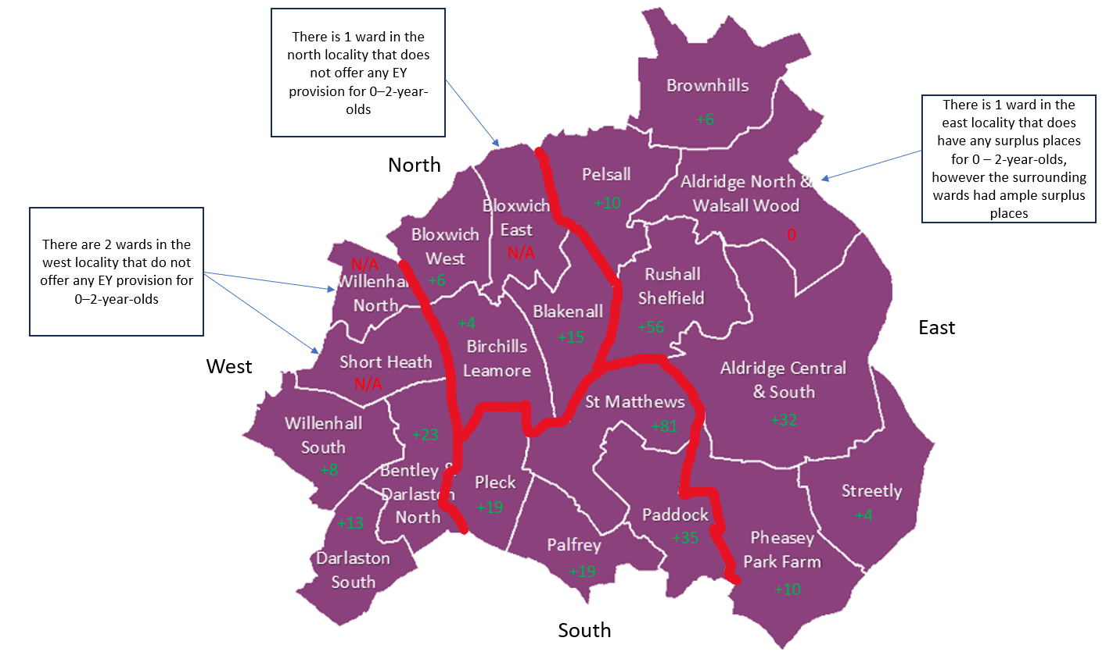
This map shows the amount of surplus places available for children aged 0 – 23 months, it is based on the supply of places being for 26 hours per child as per the DfEs guidance.

Map of surplus places for 2-year-olds
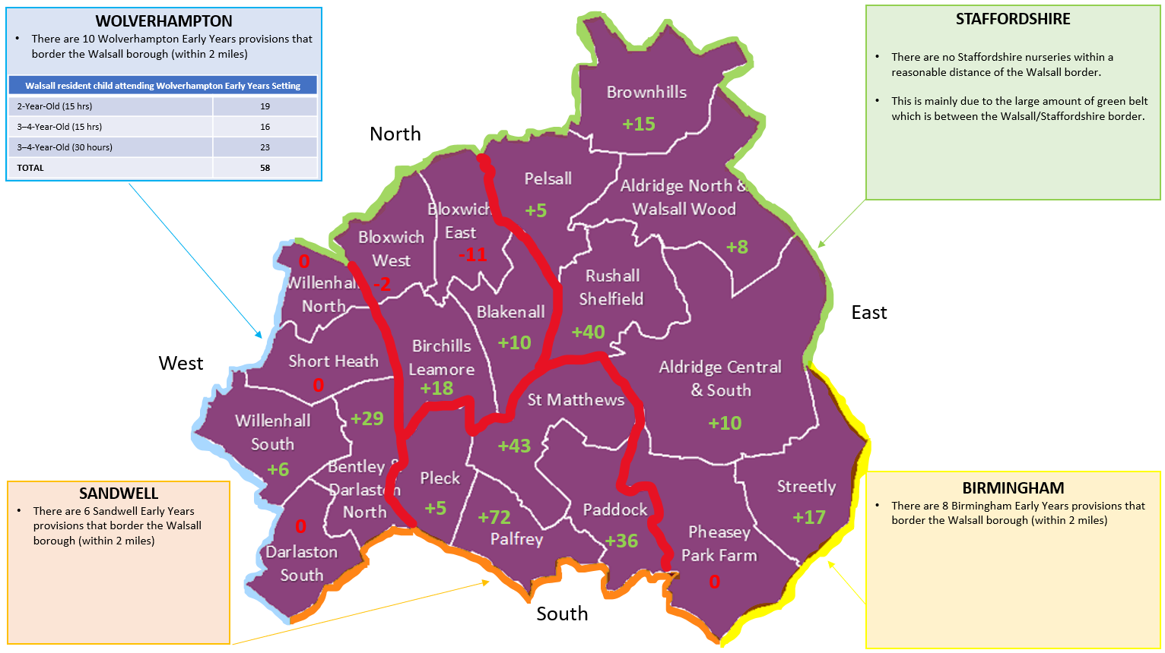
This map shows the amount of surplus places available for children aged 2 – 3 years, it is based on the supply of places being for 26 hours per child as per the DfEs guidance.
Given the DfEs Early Years and childcare expansion programme, we will be working closely with providers to forecast whether there will be a need to create additional places across all age groups within the Early Years settings.

Childcare before and after school
We are currently undertaking a review of wraparound childcare in line with the government’s childcare expansion plans. At present, there are 56 schools and PVIs in Walsall who provide before and after school childcare. There are a further 17 schools who provide before school care only and one PVI who provide after school childcare. Nine schools reported that they had a waiting list and a further 13 schools do not provide any wraparound childcare at all. We will be exploring different avenues to increase our wraparound childcare offering in the coming months.

Childcare during the school holidays
AWAITING INFO FROM HAF

Childcare for children with special educational needs and disabilities (SEND)
In line with the Early Years and childcare expansion programme, we are currently undertaking a review of childcare for children with special educational needs and disabilities.

DEMAND FOR CHILDCARE
This section details the numbers of children within Walsall. It breaks down children into three different categories.
- Population of Early Years Children (under 5 years old)
- Population of School aged children (Aged 5 to 14 years old)
- Number of children with special educational needs and disabilities

Population of early years children
In total, there are 17,344 children under the age of five living in our local authority. These children may require early years childcare.
The below table shows the breakdown, by age, of children under the age of five living in Walsall.
Table 3
Age | Number of children
Age 0 | 3,354
Age 1 | 3,493
Age 2 | 3,495
Age 3 | 3,360
Age 4* | 3,642
* Some four-year-olds will have started reception
Source: West Midlands Child Health Information Service monthly return (January 2019 to December 2023)

Population of school age children
In total there are approx. 27,539 children aged 5-11, and 11,908 children aged 12-14 living in our local authority. These children may require childcare before and after school, and/or during the school holidays.
The below table shows the breakdown, by school age, of children in Walsall.
Table 4
Age | Number of children
Age 5 | 3,790
Age 6 | 3,965
Age 7 | 3,942
Age 8 | 3,988
Age 9 | 4,010
Age 10 | 4,008
Age 11 | 3,836
Age 12 | 3,953
Age 13 | 4,000
Age 14 | 3,955
Source: Capita One extract - Pupils Currently on roll as at 29/01/2024

Number of children with special educational needs and disabilities
Children with special education needs and disabilities (SEND) are entitled to support with childcare up to the age of 18 (age 14 for children who do not have a special need or disability). The number of children (under 18 years old) with an Education, Health and Care (EHC) plan in our local authority is 3,800. The total number of CYP for whom Walsall maintains an EHC plan is 4,508.
Table 5
Age | Number of children
Birth to school age (under 5) | 262
Primary School age (5 – 10) | 1391
Secondary School (11 – 18) | 2147
Source: Capita Extract - Current list of Pupils with an EHCP, maintained by the SEND Team as at 18/01/2024 (SEN2 date)

Changes to population of children in our area
Birth data is how we forecast future demand for places within educational settings. We have seen a natural decline in Walsall which follows the trend of national and regional figures.
Table 6
Academic Birth Year | 2018/19 | 2019/20 | 2020/21 | 2021/22 | 2022/23
Number of births | 3,607 | 3,505 | 3,425 | 3,412 | 3,423
% Change from previous year | -0.39% | -2.8% | -2.3% | -0.38% | +0.32%
Source: West Midlands Child Health Information Service monthly return (September 2018 to August 2023)
In addition to this, we are seeing a much higher migration of children coming into the Walsall borough and this can be evidenced by reviewing primary school cohort growth and midyear admissions data.

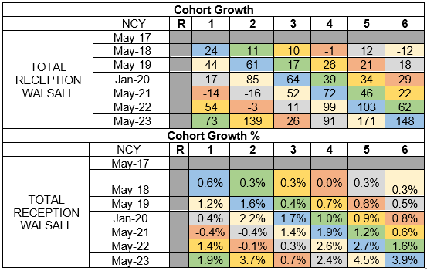
Finally, we may see an increase in working parents accessing funded hours as the governments Early Years and Childcare Expansion agenda focuses on helping parents return to work by offering 30 hours funded childcare from children 9 moths to 4 years from September 2025.

SUPPLY OF CHILDCARE
This section details the numbers of early years places within Walsall. It breaks down children into five different categories.
- Number of early years providers and places
- Early Years vacancies
- Number of school age providers and places
- School age vacancies
- School age atypical childcare

Number of early years providers and places
In total, there are 181 childcare providers in our local authority, offering early years childcare places.
The below table shows the total number of early years childcare providers in Walsall and the number of places which they offer for the different age groups.
Table 7
Type of provision | Number of providers | 25 hr places  0 – 2 Years | 15 hr places  2 Years | 30 hr places  3 – 4 Years
Childminders* | 58 | 64 | 58 | 56
Nursery classes in schools | 69 | 0 | 287 | 1,762
Maintained nursery schools | 8 | 0 | 454 | 556
Private, voluntary, and independent nurseries | 46 | 968 | 1,784 | 1,112
Total | 181 | 1032 | 2583 | 3486
* Some childminder places may also be available for older children.
Sources
- Internal data collection exercise December 2023
- DfE Local Authority Readiness data – November 2023
- Source: Childminder survey completed January 2024 (51.7% completion rate)

For private, voluntary, and independent nurseries and childminders, the number of registered places represents the maximum number of children who can be on the premises at any given time. In practice, many providers choose to operate below their number of registered places.

Early years vacancies
Vacancy rates are a snapshot, and often change rapidly. In some cases, providers may have a vacancy which is only available for a specific age group, or for a particular part time arrangement. We ask providers to report vacancies to us so we can help promote them. Not all choose to do this. In general, vacancy rates are higher in the autumn, when children move to school.
The below tables show the number of places in each locality, with early years providers, which are not currently filled. The vacant places for 0 to 2 years old are based on the DfEs recommended take up of 26 hours per week. The 3 – 4-year-old places are based on 30 hours.
Table 8
Locality | 0 – 23 month | 2 year olds | 3 – 4 year olds
North | 22 | 15 | 98
South | 160 | 156 | 189
East | 116 | 95 | 268
West | 44 | 35 | 173
Total | 342 | 301 | 728
Source: Internal data collection exercise December 2023

Number of school age providers and places
Tracking supply of childcare for school age children is difficult because not all this type of provision is registered with Ofsted. It is possible that we have under-counted the provision of breakfast and afterschool clubs. Parents may also use provision which is not considered ‘childcare’, for example sports or arts clubs after school or in the holidays.
The below table show the number of providers and the number of places that the offer for before and after school childcare.
Table 9
Type of provision | Number of providers | Number of registered places
Breakfast club – primary school | 76 | 2,534
After-school club – primary school | 77 | 1745
Breakfast club - Childminders | 13 | 49
After-school club – Childminders | 17 | 46
Source:
- Internal data collection exercise January 2024
- Childminder survey completed January 2024 (51.7% completion rate)

School age vacancies
Following a data collection which was completed in January 2023, it was established that nine schools currently have waiting lists. Most providers stated that they struggle to fill their provisions.
We are currently undertaking a new data collection with providers to effectively map supply and demand.

School age atypical
Childcare is most commonly delivered during the typical working day, between 8am and 6pm on weekdays. Some parents require childcare outside these times to fit with their work or other responsibilities. The number of providers offering childcare for atypical hours in our local authority is detailed in the table below.

Table 10
Type of provision | Number of providers | Available before 8am weekdays | Available after 6pm weekdays | Available weekends
Breakfast club – primary school | 76 | 53 |  | N/A
After-school club – primary school | 77 |  | 0 | N/A
Breakfast club - Childminders | 13 | 13 |  | N/A
After-school club – Childminders | 17 |  | 1 | N/A
Source:
- Internal data collection exercise January 2024
- Childminder survey completed January 2024 (51.7% completion rate)

FUNDED EARLY EDUCATION

Introduction to funded early education
Some children are entitled to free childcare, funded by the government. These entitlements are for 38 weeks per year.
- All children aged 3 and 4 are entitled to 15 hours per week until they start reception class in school.
- Children aged 3 and 4 where both parents are working, or from lone parent families where that parent is working, are entitled to 30 hours per week until they start reception class in school
- Children aged 2 whose families receive certain benefits (including low income families in receipt of in-work benefits), or those who meet additional non-economic criteria , are entitled to 15 hours per week. Nationally, about 40% of 2-year-olds are entitled to this offer, but the proportion varies by area.

- From 1st April 2024, working parents will be able to access 15 hours of funded childcare for 38 weeks per year for all 2-year-olds.
- From 1st September 2024, working parents will be able to access 15 hours of funded childcare for 38 weeks per year from the term after the child turns 9 months old.
- From 1st September 2025, working parents will be able to access 30 hours of funded childcare for 38 weeks per year from the term after the child turns 9 months old until they start school.
This is summarised in the table below.
Table 11 | 9 months – 2 years | 2 years | 3 to 4 years
Current Offer up to 31/3/2024 | N/A | •Eligible children - 15 hours | •All Children - 15 hours  •Working parents - 30 hours
From 1st April 2024 | N/A | •Eligible children - 15 hours  •Working parents - 15 hours | •All Children - 15 hours  •Working parents - 30 hours
September 2024 | •Working parents - 15 hours | •Eligible children - 15 hours  •Working parents - 15 hours | •All Children - 15 hours  •Working parents - 30 hours
September 2025 | •Working parents - 30 hours | •Eligible children - 15 hours  •Working parents - 30 hours | •All Children - 15 hours  •Working parents - 30 hours

Proportion of 2-year-old children entitled to funded early education.
In Walsall, 32% of 2-year-olds are entitled to funded early education. This equates to around 1,124 children per year (based on 5-year average figures – See table 2)

Take up of funded early education
The proportion of eligible children taking up their funded place (for at least some of the available hours) in Walsall is:
Table 12
Age | % of eligible children
Age 2 | 57.6%
Age 3 and 4 | 76%
Source: Data collected via Synergy and supplied by the Walsall BI Technical team based on figures from Summer 2023

PRICES
For early years childcare outside the funded entitlements, we report on average prices per hour, reported to us by settings. There may be variations to prices based on the number of hours a family uses, with reductions for longer hours, or discounts for sibling groups. There may be additional payments for additional services, e.g. lunch and other meals which are not included in these prices. The table below shows the prices charged by PVIs and Childminders.
Table 13
Provider | Hourly Rate | Session/Half day rate | Day rate | Weekly rate
Childminder | £4.38 | £6.00 | £38.40 | £192
PVI | £6.45 | £24.97 | £46.41 | £232.05
Source: Data collected via Synergy and supplied by the Walsall BI Technical team – March 2023

Prices of school age childcare
For school age children during term time, we report on average prices before school per day, after school per day, and for childminding per hour.
Table 14
Setting and price unit | Price per day
Breakfast club | £3.71
After-school club – School/PVI | £8.07
Breakfast club – Childminders | £5.52
After-school club – Childminders | £12.78

QUALITY OF CHILDCARE

Ofsted
Ofsted regulates childcare under the Early Years Register which allows flexibility in numbers of children accessing the provision. This means that childcare providers can adjust the number of places they make available for babies, 2, 3 and 4-year olds based upon staffing levels, space and the demands of their local communities.
This report shows the range of childcare by provider type, available to families across the city. Profiles for each locality will show the make-up of the population and take up of Early Education Funding.

Registration of Childcare provision
The Childcare Act 2006 gives Her Majesty’s Chief Inspector of Education, Children’s Services and Skills (HMIC) responsibility for regulating registered childcare providers.

Childcare Register
The Childcare Register is for providers who care for children from birth to 18 years. It has two parts:
- A Compulsory part, for providers who care for children aged from the end of the Foundation Stage up to seven years.
- A Voluntary part, for providers who care for children aged eight and over and those providing care for children at any age for whom registration is not compulsory, e.g. nannies.

Early Years Register
Registration on the Early Years Register is compulsory for providers who care for children in the early years’ age group; from birth to compulsory school age.

Ofsted Inspections and Judgements
Ofsted will inspect all providers who are on the Early Years Register. New providers who have registered will normally receive their first quality inspected within 30 months of registration.
Ofsted evaluates the overall quality and standards of the early years’ provision in line with the principles and requirements of the Early Years Foundation Stage. Inspectors judge the overall effectiveness of the early years’ provision, considering three key judgements:
- How well the early years’ provision meets the needs of the range of children for whom it is provided
- The contribution of the early years’ provision to the well-being of children
- The effectiveness of the leadership and management

Outstanding
The setting consistently achieves very high standards across all aspects of its work with exceptional educational programmes for children. The setting has very high expectations and a clear understanding of how children learn. Rich varied, and imaginative experiences are provided for the children. Assessment and planning are precise and sharply focused on a comprehensive knowledge of each child.

Good
There is depth and breadth across the seven areas of learning with experiences which are interesting and challenging and meet the needs of all children. There is secure knowledge and understanding of how to promote the learning and development of young children and what they can achieve. Regular and precise assessments of children are made and used to plan suitably challenging activities, so that children of all ages and abilities make good progress in their learning.

Requires Improvement
The provision is not yet demonstrating the characteristics of a good judgement. However, any breaches of the statutory requirements for learning and development do not have significant impact on children’s learning and development.

Inadequate
If there are breaches of the statutory requirements for learning and development which have a significant impact on children’s learning and development e.g. the seven areas of learning are inadequately provided and/or do not provide interesting activities in enough depth or breadth; some practitioners have a poor understanding of the areas of learning and/or knowledge of how to promote children’s learning and development; planning is not effective in matching activities to children’s needs; observations and assessments are not consistent in quality.
Where there are no children on roll, the inspector must make it clear at the start of the inspection (or during the initial telephone call) that the inspection will not be a full inspection but a check that the provider continues to be suitable to remain registered. As a result, no grades will be given, the inspector will make a judgement only on the ‘overall quality and standards of the early years provision’ with one of the three possible outcomes:
- Met (where a judgement is ‘met’, the inspector will not make recommendations)
- Not met with actions
- Not met with enforcements
For provider registered on the Childcare Register the Ofsted Inspector will make a judgement of two possible outcomes:
- Compliant (meeting all the requirements for registration on the Childcare Register)
- Non-compliant (not meeting all the requirements for registration on the Childcare Register

Quality of childcare in Walsall
The below table shows the different types of provision and the ratings that they hold.
Table 15
Type of provision | Total number of providers | % achieving good or outstanding
Childminders | 58 | 98.3%
Nursery classes in schools * | 69 | 91.3%
Maintained nursery schools | 8 | 100%
Private and voluntary nurseries | 43 | 95.3%
Total | 178 | 96.23%
Source: Walsall Ofsted Summary – December 2023

Providers with met/not met grade
When providers do not have any children on site at the time of their first inspection, they are given an Ofsted grade of ‘met’ or ‘not met’. This shows whether they are meeting the requirements for Ofsted registration, and usually happens when new providers are being set up.
In Walsall we have two providers with a ‘met’ grade and one provider with a ‘not met’ grade. In addition to this, there are five schools who have nurseries who have an Ofsted status of ‘requires improvement’ and one who has an Ofsted status of ‘inadequate’.

EARLY YEARS AND CHILDCARE EXPANSION PROGRAMME

Spring Budget 2023
In the Government’s Spring Budget 2023, the Chancellor announced transformation reforms to increase availability, reduce costs and increase the number of parents using it. By 2027-28, this government expect to spend in excess of £8bn every year on free hours and early education, helping working families with childcare costs. This will include £4.1bn to funded extended free hours for children over the age of 9 months, a funding rate increase for childcare providers, increasing the supply of wraparound care, and wider market reforms.
Summary of Reforms:
- Changes to staff to child ratios for 2-year-olds, from 1:4 to 1:5
- Increase to the hour funding rate for providers.
- 15 hours for working parents of 2-year-olds, extending to 15 hours for working parents of children 9 months +
- Extending the 15 hours to 30 hours for working parents of children 9 months to school age
- Grants available to those wanting to register with Ofsted or with a Childminder Agency as a Childminder
- Ensuring that all schools offer 8am-6pm wraparound care.
These reforms will be rolled out in stages, to ensure there is enough supply for the demand. The following chart shows the expected phased roll out.

Autumn 2023
- Childminder grants become available.
- Investment of £204m into early years funding rates
- Staff: child ratio change (1:5)

April 2024
- 15 hours funded for working parents of 2-year-olds introduced.
- Investment of £288m into early years funding rate for providers

September 2024
- National wraparound support begins.
- 15 hours for working parents of children 9 months + introduced.

September 2025
- 30 hours for all working parents of children from 9 months to primary school age introduced.

September 2026
- All schools to offer 8am - 6pm wrap around care on their own or in partnership with other schools or childcare providers.

RECOMMENDATIONS
To ensure the Local Authority meets the Statutory Duty to secure sufficient childcare, so far as is reasonably practicable, the following areas have been identified.

Supply and demand of childcare
Walsall council will continue to monitor the take-up of childcare and will support childcare providers to maximise their occupancy and remain sustainable. Closer analysis of future demand for childcare in readiness of the new reforms will help us ensure sufficient places for both working families as well as supporting the needs of our disadvantaged families.
The Early Years Quality Assurance Team will continue to provide advice, guidance, and challenge to ensure all accessing provision experience high quality early education.
Actions:
- To complete termly data collection with providers to effectively map supply and demand of places, ensuring that the new childcare reforms are implemented smoothly.
- To closely monitor the take up of childcare for under two-year-olds.

Eligibility and entitlements take-up
Parents need to know their entitlements and childcare providers need to be supported to provide places for free entitlement. At Walsall council we will provide clear information on all early education funding entitlements through the Families Information Services website and via direct contact with the providers. We will continue to work with providers to maximise their occupancy and individual setting’s funded offer, to meet the needs of families.
Actions:
- All providers have effective tools, skills and information to enable them to promote all funded childcare options
- To ensure all information is clear and accessible to parents and professionals working with families
- To continue to promote childcare and the importance of early education

Capacity and recruitment
Staff recruitment and retention continues to be a risk to the childcare market both nationally and locally. Ensuring childcare providers continue to meet parents’ needs must be monitored. Walsall will continue to promote childminding as a business opportunity and has also been selected to take part in the government financial incentive scheme to encourage candidates to join or rejoin the early years sector. We will continue to work with local colleges and the university to promote careers within the childcare sector. We will also continue to work with DWP and Walsall Employability and Skills board.
Actions:
- Ensure local colleges/schools are offering the required Early Years qualifications and explore how these are offered and promoted.
- Work with the university to help place competent practitioners into Early Years jobs.
- Promote the Early Years financial incentives scheme with providers to get as many eligible candidates as possible into positions to build capacity within the sector
- Continue to work with DWP and Walsall Employability and Skills board.

Communications and Marketing
Parents must have access to information on the availability of childcare across the borough, early years funding entitlements (criteria and application process). Some families may need extra support, where gaps in provision prevent them accessing suitable childcare. Therefore, Walsall council will continue to support families to find appropriate childcare. We will ensure families have access to up-to-date online information that will help parents make informed choices through the Families Information service (01922 653383) Walsall FIS Homepage (mywalsall.org). We will also continue to work with our internal partners and publish news items and social media posts to reach as many families as possible.
Actions:
- Information for families must be current and available in a range of formats.
- Information should be easily accessible and up to date.
- Information to be provided to families at the earliest opportunity (best start for life booklet/baby buddy and easy peesey app)

Available to families where each parent (or one parent in a single adult household) are earning the equivalent of working sixteen hours per week on the minimum wage.

