Dear X / Greeting,
Nursery – where the best start happens
We are writing to you to share how we, as your nursery, ensures we provide the best possible start for children. The Government has a national strategy for ‘Giving Every Child the Best Start in Life’ and we wanted to share how we are already doing the things set out in this.
Better Support for families
Nurseries/pre-schools like ours provide support for families in every community. We offer rich, play-based learning environments tailored to the needs of each individual child.
When it comes to being embedded in the community, as you know we (include examples of community focussed work you do like: foodbank support, community engagement, bringing family or community members into settings etc.)
We also support children and families with additional needs by (insert types of support available for children and ways you help families – eg. Sensory rooms/resources, additional staffing for 1-2-1 support etc)
Unfortunately, support for children with additional needs is becoming increasingly stretched. Private and voluntary nurseries like ours are providing more places for children with additional needs than any other part of the early years sector but often we do not get the financial support to do everything that children need in ways that we would want to.
The Government has started a national conversation on SEND provision and we would encourage you to find out more including how you can be involved here - https://www.gov.uk/government/news/government-launches-national-conversation-on-send
More accessible early education and childcare
Nurseries/ pre-schools like ours are proud to be part of the private, voluntary and independent (PVI) sector which is working hard to deliver the majority of the Government’s funded childcare expansion. We have increased our capacity by XX funded places / now deliver XXX funded places to make sure families can get their funded places.
We are open XX weeks a year and XX hours a day to make sure the early education and care we offer is supporting families while also offering the vital continuity of care for our children. That’s how nurseries like ours are delivering early education and care that works for everyone.
However, we also need the funding system to work for nurseries. The National Day Nurseries Association (NDNA) has found that nurseries make an average loss of £2 per hour on funded places for three and four year-olds. The Government’s own research says that only 42% of nurseries across the country have enough income to cover our costs and for school based nurseries only 23% say they can cover their costs, so the whole system is clearly underfunded.
The Government says it’s hourly funding rate “is not intended to cover the costs of meals, other consumables, additional hours or additional services”. This is why we have charges in place for meals, snacks, items like nappies or the things we do over and above the requirements of the EYFS like [insert activities here]
We know the range of funding options and support can be difficult to navigate, which is why we are backing calls for changes to the way early years funding is allocated to make it simpler for you, us and our local authority. If we could spend less time doing paperwork and admin for the funded hours, we could spend more time with your children.
Improving quality in early years
We are proud to be providing your child with the inspirational early experiences that we know make a difference to learning and development in those crucial first five years. The Government’s national target is for more children to be reaching a good level of development in the Early Years Foundation Stage, up to when they start school at five.
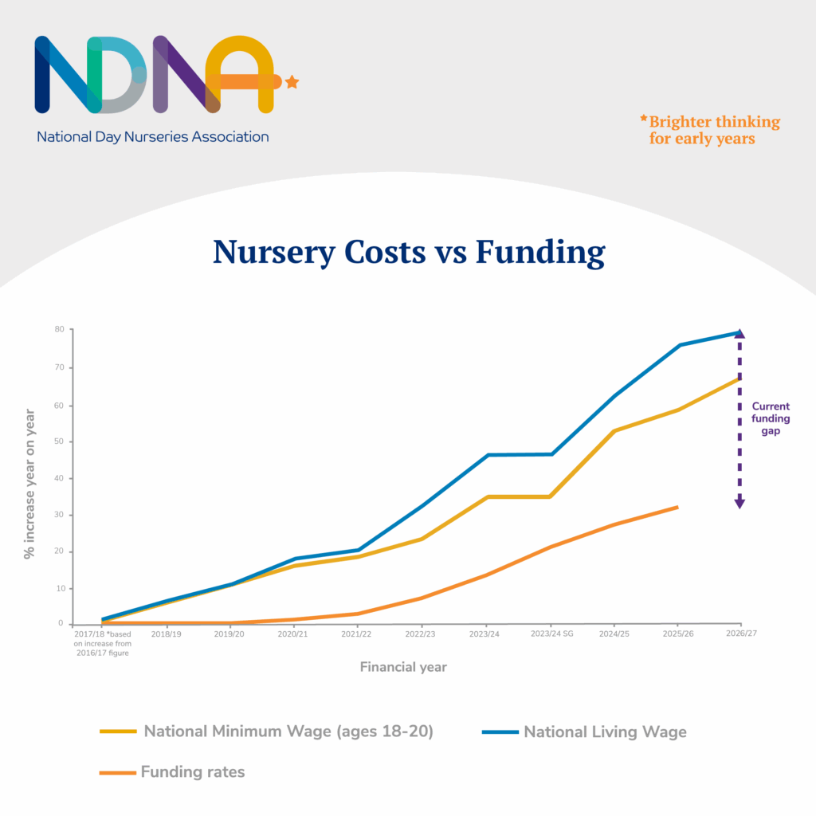
We take a wider view here. Inclusive education and care in nursery means no child is left behind and our quality starts with skilled, experienced early years educators. Our team contains qualified staff who have expertise in child development, as well as specialists in [SEND, maths, physical activity etc]
With growing costs across the board and funding failing to keep pace with these costs every year, we are doing this in a very challenging environment. In the coming weeks the Government will announce new funding rates for our area but as you can see from this chart, there is a significant and growing gap between our staffing costs and the funding we receive.
For context, the average funding rate for three and four-year-olds only increased by 4.6% last year when we saw statutory wages rise by around 10%. This year the statutory wage increases will be between 4.1% and 8.5% and we need that to be reflected in Government funding.
We will be supporting NDNA’s national campaign Nursery – where the best start happens, to showcase the amazing things that are happening in our nursery and nurseries and pre-schools like ours across the country. We will share some of these with you and it would be great if you could share them as well.
As part of this campaign, we will also be writing to our local MP XXXXXX to highlight some of these challenges with them. If you are able to contact them with your concerns it could help ensure that the Government provide better support to early years, to minimise the increased costs we have to pass on to parents.
I hope this information helps you to understand the challenges we face as nursery providers and the difficult choices we are faced with. We also hope you will be able to support us in contacting our MP to ask for the support early years providers need.

Sign off

